Hello Nursery
It’s a snow day!!!

Today is all about learning everything you can about snow, we talked about it at school and now we have the chance to experience it for ourselves!!

While you are playing outside in the snow:
- Make a snowman by rolling 3 balls of different sizes and putting them on top of each other like mine below. Dress the snowman as best you can and take a photo.
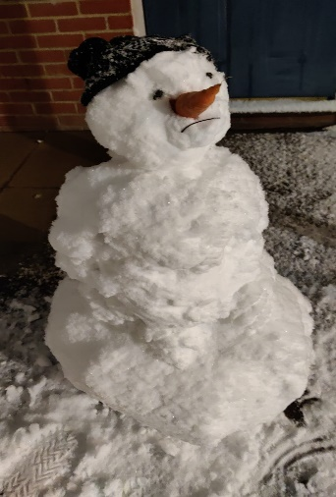
I made this one last night, he looks a bit lonely! May be needs a friend, and some more clothes.
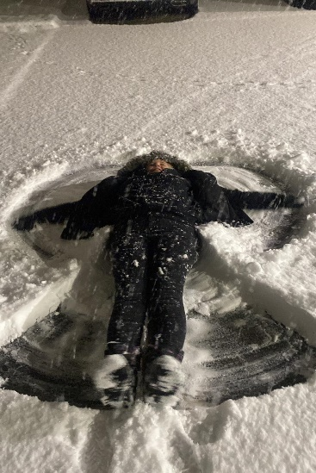

- Make a snow angel, this is fun to do and they look great!
Just open and close your legs again and again and lift your arms up and down at the same time and then carefully get up and check out your snow angel, take a photo so we can see it at school.

- Take some snow inside the house in a bucket. Remove your gloves and feel the snow.
What does it feel like on your hand, on your nose and on your tongue?
What does it sound like when you walk on it or press it tight together?
Is a snow flake heavy or light?
What about a snow ball or a snow man? When you carry lots of snow all at once?

Think of words you can use to describe the snow. And ask a parent to write them all down.
Send them in to school with your photos by email. Which I will leave below.
Now hold some of the snow tight in your palm. Can you guess what is going to happen?
Describe this in your own words.
Snow is very strange. Now think about all these questions and remember the answers so we can talk about it at school.
Where does it come from?
What is it made of?
How does it turn into snow?
What needs to happen for snow to fall?
How does snow disappear? What does snow look like and feel like when it disappears?
Take some photos of you in the snow as well as the trees and plants around you.

Email all your responses and photos to this email address and we will look at them together in class next time we see each other
Schoolnursery@barleylane.redbridge.sch.uk

